

FRS for: NOKIA_WDM

FRS (Functional Requirement Specifications)
Auto-Import

Draft version 0.1
2025-10-14

Change History

Version | Change Description | Author | Date
0.1 | First draft. | Azmat Ali | 14/10/2025

Preamble:

- This document has been created to parse NOKIA DWDM physical & logical inventory.
- Note: - Please remove the space after attributes if it has.

Physical Details
- We are parsing physical details from dump “Hardware_Inventory_XX_XX_UTC”.

1.1 Node Detail

The Node details parsed from dump file starting with “Hardware_Inventory”

Attribute | Staging DB Attribute | Importance | Comment
NE ID | Batch_Network_Element/  NEID | [Mandatory] | - Take the value under attribute “PrimaryIP”.
Object ID | Batch_Network_Element/  OBJECTID |  | - Node ID
Node Name | Batch_Network_Element/  NAME | [Mandatory] | - Need to take the value under the attribute “NE”.
Manufacturer | Batch_Network_Element/  ManufacturerName | [Mandatory] | - By Default, Manufacturer “NOKIA”
Site ID | Batch_Network_Element/  SITE | [Mandatory] | - Site ID need to be parse on the basis of naming convention under attribute “NE”.  - Site ID need to be taken after ‘PSS_’ & need to ignore “_”.  Ex: PSS_TUN_9002 TUN9002  - If there is suffix added in site id with “-“ then need to ignore that.  Ex: PSS_NAB_9236-TR NAB_9236
Model | Batch_Network_Element/  NEMODEL | [Mandatory] | - Need to be taken from “Node Type” attribute.  Ex : 1830 PSS-32
Type | Batch_Network_Element/  NETYPE | [Mandatory] | = WDM
SW Version | Batch_Network_Element/Verssion | [Mandatory] | - = SW Release

1.2 Cabinet & Shelf Detail

- Shelf details parsing from dump “Hardware_Inventory”.

ID | Batch_Node_Cabinet/ID |  | - Need to be taken from attribute PrimaryIP
Cabinet index | Batch_Node_Cabinet/  CABINETINDEX  Batch_Node_Cabinet/  CABINETTYPE  Batch_Node_Cabinet/  NodeID | [Mandatory] | - To add one cabinet by default to each node  - Cabinet Index=1 by default  - Cabinet Type= Node Type (1830 PSS-32)  - Node ID
Shelf index | Batch_Node_Shelf/  SHELFINDEX | [Mandatory] | - Need to take Shelf index form column Shelf Against the SHELF in Aid.  - Board for which shelf are not available, take the value from column Shelf, & Shelf type would be the board type under the Unit Type  Ex:
  PrimaryIP | Aid | Unit Type
  128.5.12.126 | DCM-25-1 | DCM
Shelf Type | Batch_Node_Shelf/  SHELFTYPE | [Mandatory] | - Need to be taken under attribute “Unit Type” Against the SHELF in Aid.
Shelf Model | Batch_Node_Shelf/  Model |  | - Need to be taken under attribute “Unit Type”
Shelf Start RU index | Batch_Node_Shelf/  startRu |  | - There are 4 shelves in Nokia WDM.  1 - PSS-32 Shelf: For this shelf startRU index will be 1, if this shelf repeats then take startRU 9 for second shelf & 17 for 3rd & so on, with gap of 8, see table 2.  2- SFD44 : for this startRU index will be 9, if same shelf repeats, then startRU index will 12 with gap of 3 and so on.  If PSS-32 Shelf repeats, then take startRU +3 from last startRU for SFD44 ..see table 2 diagram.  3. DCM : Its startRU index will come after SFD44 RU index with the Gap of 3 & same condition will repeat like SFD44.  4. PSC1-6 :- Its RU index will start after DCM with the gap of 3, repetition condition will follow as SFD44.  Ex: If PSS-32 Shelf/SFD44/DCM/PSC1-6 shelf does not repeat  Table-1  If one of shelves repeat, then  Table-2  Same rule will follow for DCM & PSC shelf, if they repeat.
  Shelf Type | Start RU
  PSS-32 Shelf | 1
  SFD44 | 9
  DCM | 12
  PSC1-6 | 15
  Shelf Type | Start RU
  PSS-32 Shelf | 1
  PSS-32 Shelf | 9
  PSS-32 Shelf | 17
  SFD44 | 25
  SFD44 | 28
  DCM | 31
  PSC1-6 | 34
Serial Number | Batch_Node_Shelf/  SerialNumber | [Mandatory] | - = Serial Number
Part Number | Batch_Node_Shelf/  PartNumber | [Mandatory] | - = Unit Part Number
Manufacturer Name | Batch_Node_Shelf/  ManufacturerName |  | - = Nokia
Manufacturing Date | Batch_Node_Shelf/  ManufacturingDate |  | - =Date (DD/MM/YYYY)

1.3 Board Detail

- Board details are parsing from dump “Hardware_Inventory”.

ID | Batch_Element_Node_Board/ID | [Mandatory] | - Need to be taken under attribute “PrimaryIP”
Board Slot(C/Sh/S/I) | Batch_Element_Node_Board/  BoardIndexOnSlot | [Mandatory] | - For Board, we are considering those values under “Aid” attribute which have only shelf & slot index.  Ex: 130SCX10-1-10, Shelf index = 1 & Slot Index = 10  - Index on slot = 0
Board Type | Batch_Element_Node_Board/  BoardTypeCode | [Mandatory] | - Need to be taken this attribute under “Unit Type”
Board Model | Batch_Element_Node_Board/  Model | [Mandatory] | - This attribute needs to be taken under attribute “Mnemonic”  - In case of N/A in Mnemonic, take the value from “Unit Type” column
Board Serial Number | Batch_Element_Node_Board/  SerialNumber | [Mandatory] | - Can be deduced from dump file under “Serial Number”
Part Number | Batch_Element_Node_Board/  PartNumber | [Mandatory] | - Can be deduced from dump file under “Unit Part Number”
Manufactured Date | Batch_Element_Node_Board/  ManufacturingDate | [Mandatory] | - Can be taken under attribute “Date (DD/MM/YYYY)”
Manufacturer | Batch_Element_Node_Board/  ManufacturerName | [Mandatory] | - By Default, Manufacturer “Nokia”
SW Version | Batch_Element_Node_Board/  Version |  | - Need to be taken under attribute “Software Load”

1.4 Interfaces Detail

- Interfaces details need to be taken from dump “Hardware_Inventory”

Attribute | DB attribute | Importance | Comments
ID | Batch_Node_Interface/  ID | [Mandatory] | - Take the ID under attribute “PrimaryIP”
Slot index |  | [Mandatory] | - For interface we considering only those values which have shelf, slot & port indexes under “Aid” attribute.  Ex: 130SCX10-1-10-C1 1 is shelf, 10 is slot & C1 is port but we have considered only numerical port value & need to discard alphabet.  - Cabinet index = 1  - Shelf index = First numeric value  Ex: 130SCX10-1-10-C1 1  - Slot index = Second numeric value  Ex: 130SCX10-1-10-C1 10  - Index on slot = 0
Port Index | Batch_Node_Interface/  InterfaceIndex | [Mandatory] | - Port index = last value (only consider numerical value)  Ex: 130SCX10-1-10-C1 1  If port repeat on same slot, then do increment in port index from its last highest value in dump.  - We need to pass OSC/OSCSFP in node interface  - For port OSC/OSCSFP take port index 5 by default  - Ex: ALPHG-1-2-OSC, here shelf index would be 1 & Slot index 2 & index on slot by default 0 & port index by default 5
SFP description | Batch_Node_Interface/  SFPDescription | [Mandatory] | - The SFP description is provided in the dumps under attribute “Unit type”
Description | Batch_Node_Interface/  Description | [Mandatory] | - Need to be taken from attribute “Acronym Code”
Serial number | Batch_Node_Interface/  Serial | [Mandatory] | - Can be deduced from dump file under “Serial Number”
Part Number | Batch_Node_Interface/  PartNumber | [Mandatory] | - Can be deduced from dump file under “Unit Part Number”
Frequency | Batch_Node_Interface/  Channel | [Mandatory] | - Can be deduced from dump file under “Frequency”
Manufacturer |  |  | - By Default, Manufacturer “Nokia”

2.0 Logical Configuration

2.1 Transmission Link

- We are parsing transmission link info from dump “WDM-Connection”.
- Considering OTS link only in connection rate which have different node name A & Z end NE.

Attribute | DB Attribute | Importance | Comments
Node 1 ID | Batch_Element_TR_Link/  Node1 | [Mandatory] | - Take the name from “A END NE” & then take its respective id from network element.
Node 2 ID | Batch_Element_TR_Link/  Node2 | [Mandatory] | - Take the name from “Z END NE” & then take its respective id from network element.
Site 1 | Batch_Element_TR_Link/Site1 | [Mandatory] | - = the site of node 1
Site 2 | Batch_Element_TR_Link/Site2 | [Mandatory] | - = the site of node 2
Node 1 interface id | Batch_Element_TR_Link/  Rack1  Batch_Element_TR_Link/  SubRack1  Batch_Element_TR_Link/  BoardIndex1  Batch_Element_TR_Link/  SlotIndex1  Batch_Element_TR_Link/  InterfaceIndex1 | [Mandatory] | - Cabinet id= 1  - Shelf id= take the first numeric value after “-“.  Ex : A2325A-1-6-LINE  - Slot index= take the second numeric value  Ex: A2325A-1-6-LINE  - Index on slot= 0  - Port index=1 for LINE & LINEIN/LINEOUT
Node 2 interface id | Batch_Element_TR_Link/  Rack2  Batch_Element_TR_Link/  SubRack2  Batch_Element_TR_Link/  BoardIndex2  Batch_Element_TR_Link/  SlotIndex2  Batch_Element_TR_Link/  InterfaceIndex2 | [Mandatory] | - Cabinet id= 1  - Shelf id= take the first numeric value after “-“.  Ex : IROADM-1-2-LINEIN  - Slot index= take the second numeric value  Ex: IROADM-1-2-LINEIN  - Index on slot= 0  - Port index=1 for LINE & LINEIN/ LINEOUT
Capacity | Batch_Element_TR_Link/  TRLinkCapacity | [Optional] | = null
Type | Batch_Element_TR_Link/  Tipe | [Mandatory] | - wdm
Name | Batch_Element_TR_Link/Name |  | - Node1 Name_Node2 Name-wdm

2.2 Lambdas

2.2.0 Lambda Service
- We are taking lambda service details from the HTML file “Full_Route.html”
- In this document data is divided into different main route class under SERVICE & TRAIL IDs.
- Increment by +2 in client port for board 11DPM12 & +4 for board 11QPA4, for remaining need to increment only by +1.

Attribute | Importance | Comments
Id |  | - This id needs to be taken from tboady class under service from [ID ].  Ex: 1/ODU2/Tabarka/AIN_DRAHEM OTU2#1:1 ODU2:1 ODU1:1 DSR:1  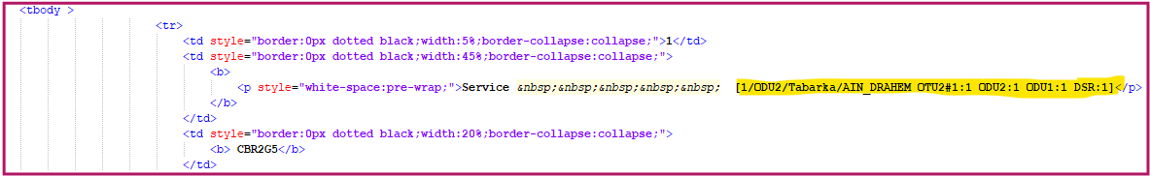
name |  | - Same as id
lambdaLevel |  | - Service
startNodeId | [Mandatory] | - Need to take node id under the first <p>******* MAIN ROUTE *******</p> class.  - Match the node id as per route first node  - Need to take under first <tr> class in 2nd line after > and before /  - Ex: >startNode/  - PSS_JEN_9109/11STMM10-1-17C10PSS_JEN_9109  - Take the id from NE report against the name PSS_JEN_9109  Ex: PSS_JEN_9109 128.5.12.9  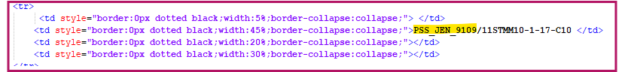
endNodeId | [Mandatory] | - Need to take node id from first <p>******* MAIN ROUTE *******</p>  - Need to take under last <tr> class in 2nd line after > and before / .  - Ex: >endNode/  - PSS_JEN_9068/11STMM10-1-17-C10PSS_JEN_9068  - Take the id from NE report against the name PSS_JEN_9068  Ex: PSS_JEN_9068 128.5.12.68  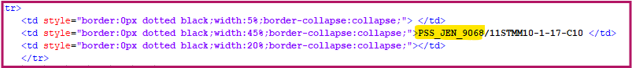
startLineInterface | [Mandatory] | Shelf, slot & port need to be taken from same class & same line  - Cabinet id= 1  - Shelf id= 1st value after board  - Slot index= 2nd value after board  - Index on slot= 0  - Port index= third value after board(take only numeric)  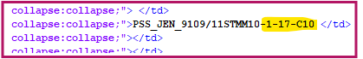  Ex: Shelf-1, Slot-17, Interface-10  Note - Increment by +2 in client port for board 11DPM12 & +4 for board 11QPA4, for remaining need to increment only by +1.

endLineInterface | [Mandatory] | Shelf, slot & port need t taken from same class  - Cabinet id= 1  - Shelf id= 1st value after board  - Slot index= 2nd value after board  - Index on slot= 0  - Port index= third value after board(take only numeric)  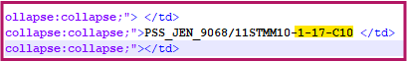  Ex: Shelf-1, Slot-17, Interface-10  Note - Increment by +2 in client port for board 11DPM12 & +4 for board 11QPA4, for remaining need to increment only by +1.
Layer Rate | Optional | Need to take the layer rate under tboady class, below the service line as below  Ex: CBR2G5  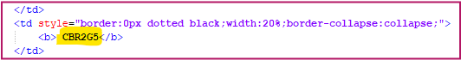

2.2.1 Lambda Route
We are taking lambda route details from the same HTML file “Full_Route.html”

Attribute | Importance | Comments
Id |  | - Need to take id above the ***Main Route***(which contains the layer rate OTU) under the trail from [ID].  Ex: 1/ODU2/Tabarka/AIN_DRAHEM OTU2#1:1  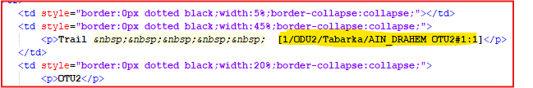
name |  | - Same as id
startNodeId | [Mandatory] | - Need to take start node id from same class.  - Need to take node id from that MAIN ROUTE from first tr class after > & before/.  Ex: PSS_JEN_9068/11STMM10-1-17-L1 PSS_JEN_9068  Take id against name from XML NE report.  Ex: PSS_JEN_9068 128.5.12.68  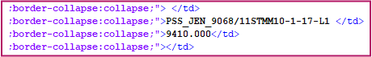
endNodeId | [Mandatory] | - Need to take end node from next L1 line in same class.  Ex: PSS_JEN_9109/11STMM10-1-17-L1-1 PSS_JEN_9109  Take id against the name from NE report  Ex: PSS_JEN_9109 128.5.12.9  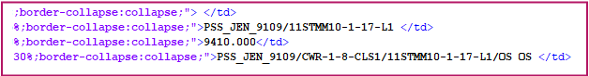
startLineInterface | [Mandatory] | Shelf, slot & port need to be taken from same class of startnode id  - Cabinet id= 1  - Shelf id= take the 1st value after board  - Slot index= take the 2nd value after board  - Index on slot= 0  - Port index= take the 3rd value after board(only numeric)  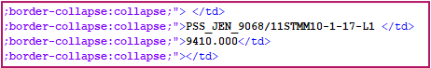  Ex: Shelf-1, Slot-17, Interface-1

endLineInterface | [Mandatory] | Shelf, slot & port need to be taken from same class of endnode id  - Cabinet id= 1  - Shelf id= take the 1st value after board  - Slot index= take the 2nd value after board  - Index on slot= 0  - Port index= take the 3rd value after board(only numeric)  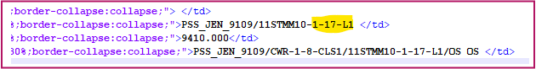  Ex: Shelf-1, Slot-17, Interface-1
frequency |  | - Can be taken under OUT p>******* MAIN ROUTE *******</p>.  - Need to take from 1st tr class  - Need add 1 in suffix in frequency then devide by 100  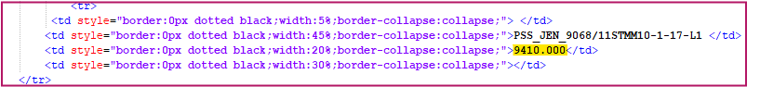  Ex: 941019410/100=194.10
lambdaLevel |  | ROUTE
Layer Rate | Optional | Layer rate need to take under the line Trail  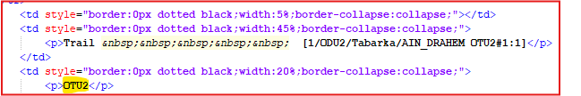  Ex: OTU2

2.2.2 Lambda Route Hopes

- Need to be taken route hopes from the file Full_Route.html
- Details need to take under that ***Main Route*** which contains OTU layer rate.
- Need to make hopes between tr classes from top to down.
- We need to make hopes form L1/2 to L1/2 & no need to repeat again.

OTU Main Route

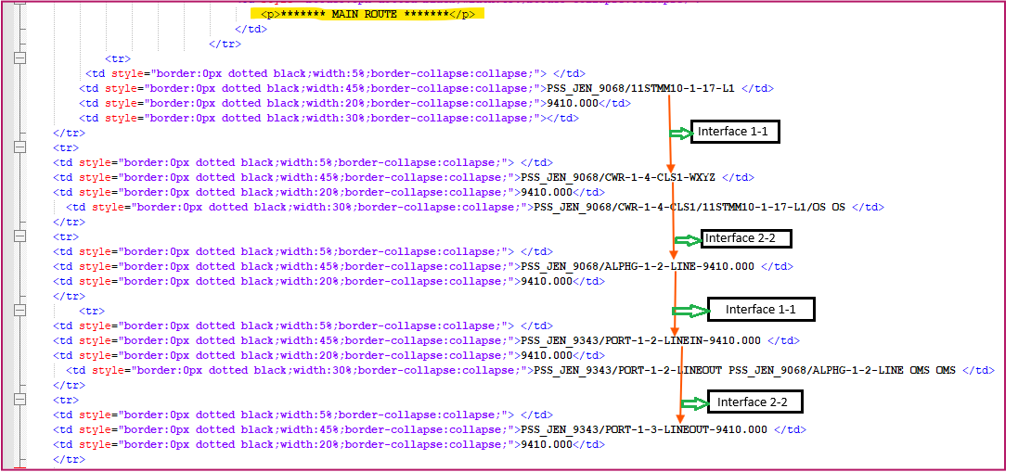

Attribute | Importance | Comments
Id |  | - ID needs to be taken same as Lambda route rule(from same class)_route indexing
lambdaRouteId |  | - ID without indexing
Node1ID |  | - Details need to take under OTU ***Main Route***  - Take node1 name from 1st tr class between two special characters >nodename/, then take id against the name from NE report.  Ex: Node1 Name PSS_JEN_9068(128.5.12.68)  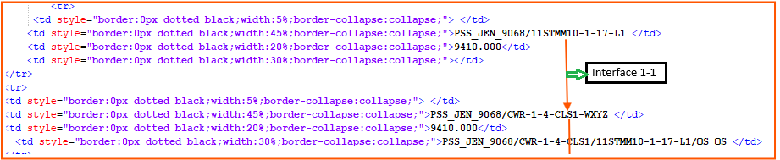  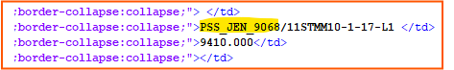
Node2ID |  | - Take node2 name from next tr class between two special characters >nodename/, then take id against the name from NE report.  Ex: PSS_JEN_9068 128.5.12.68  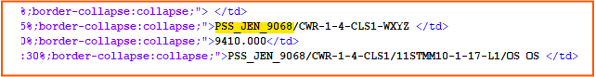
interface1Key |  | - Interface1 detail is available after the node name in same line of same tr class  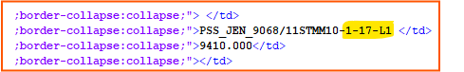  Cabinet index = 1 (by default)  Shelf index = 1 (1st value after board 11STMM10)  Slot Index = 17 (2nd value )  Index on slot = 0 (by default)  Port index = 1 (3rd numerical value)  There are some conditions to fetch port.  - For the first & last hops, take the same port if it’s there.  - For the next hop, take port 2 if the same board is repeating on the same node.  - For the next hop, take port 1 if nodes are different.  - If port contains more than 2 numeric digits, then consider port-1 for first hop & port-2 for second hop.
interface2Key |  | - Interface2 detail is available after the node name in same line of same tr class  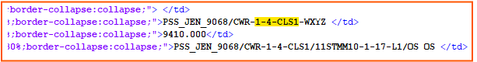  Cabinet index = 1 (by default)  Shelf index = 1 (1st value after board 11STMM10)  Slot Index = 17 (2nd value)  Index on slot = 0 (by default)  Port index = 1 (3rd numerical value)  There are some conditions to fetch port.  - For the first & last hops, take the same port if it’s there.  - For the next hop, take port 2 if the same board is repeating on the same node.  - For the next hop, take port 1 if nodes are different.  - If port contains more than 2 numeric digits, then consider port-1 for first hop & port-2 for second hop.
indexOnRoute |  | - It will be in increasing order like for first hop it will 1 & for 2nd hop it will be 2 & so on.
isHopLink |  | - If node1 & node2 are same, then it will false else it will be true.

2.2.3 Lambda Service Hopes

- For the lambda service hop we need to consider same route hopes, just we have to add two more hopes in lambda route hopes 1st in starting & 2nd in last.
- We have to follow same approach to parse the node id & interface key for 1st & last hop.
- We have to take this data from first ***Main Route*** & OTU Main Route.
- For the first hop, we have to map OUT Main Route first L1 node id with 1st Main Route first & last line node ID as shown below then take client interface Interface1key & line port interface2key.
- For the last hop, we have to map next L1 node id with 1st MR first & last node id as shown in below diagram then take line port for interface1key & client port interface2key.
- Increment by +2 in client port for board 11DPM12 & +4 for board 11QPA4, for remaining need to increment only by +1.

1st & OTU Main Route

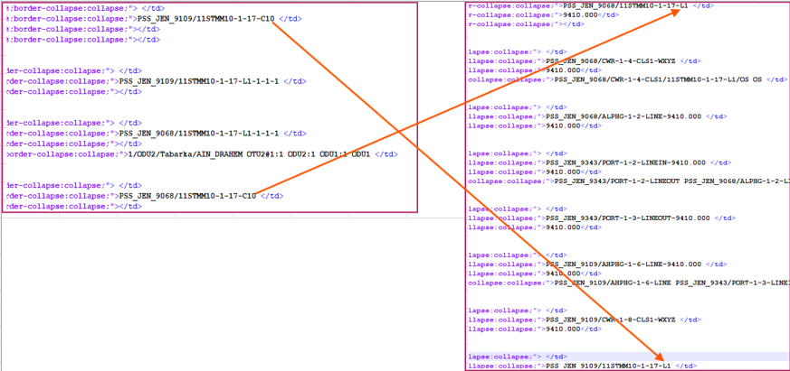

2.2.4 Signal Flow
- For Signal flow we are considering the same file Full_Route.
- Need to Signal flow data from 1st Main Route & OTU main route.
- Signal flow connection exists only in same node not between different nodes.
- Increment by +2 in client port for board 11DPM12 & +4 for board 11QPA4, for remaining need to increment only by +1.

OTU Main Route

Attribute | Importance | Comments
Id | [Mandatory] | Id format - Node1ID_Node1ID:interface1id_interface2id  - Take IP against the node name available in tr classes.  Ex: PSS_JEN_9109 128.5.12.9  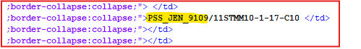
Node ID | [Mandatory] | - Need to take node id from NE report against the node name.  Ex: PSS_JEN_9109 128.5.12.9
interface1Id | [Mandatory] | - Interface id available in same 1st tr class after board  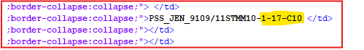  Cabinet index = 1 (by default)  Shelf index = 1 (1st value after board 11STMM10)  Slot index = 17 (2nd numerical value)  Index on slot = 0 (by default)  Port index = 10(3rd numerical value)  Note – Port incremental rule will be applied as per the board.  There are some conditions to fetch port.  - For the first & last hops, take the same port if it’s there.  - For the next hop, take port 2 if the same board is repeating on the same node.  - If port contains more than 2 numeric digits, then consider port-1 for first hop & port-2 for second hop.
Interface2Id | Mandatory] | - Interface id available in same 2nd tr class after board for same node  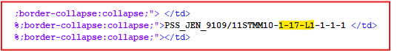  Cabinet index = 1 (by default)  Shelf index = 1 (1st value after board 11STMM10)  Slot index = 17 (2nd numerical value)  Index on slot = 0 (by default)  Port index = 1 (3rd numerical value)  Note – Port incremental rule will be applied as per the board.  There are some conditions to fetch port.  - For the first & last hops, take the same port if it’s there.  - For the next hop, take port 2 if the same board is repeating on the same node.  - If port contains more than 2 numeric digits, then consider port-1 for first hop & port-2 for second hop.
signalFlowRole |  | - Main

